**REDANT TASK**

**TASK NO. 2**

**Django App Creation:**

The user detail is to be maintained by a security for which we need an admin panel and a database connection for him to enter user details and save them for future use.

Hence we create an django app to store the user details in the database. So the steps to create an django app are:

* The project MyApp is created using the command

**django-admin startpoject MyApp**

* An application is created that is an app is started using the command

**python manage.py startapp Security**

* In **settings.py**  file we have to make some changes to connect the **postgresql** engine with django . Like we have to add the host name, database name, user name and password

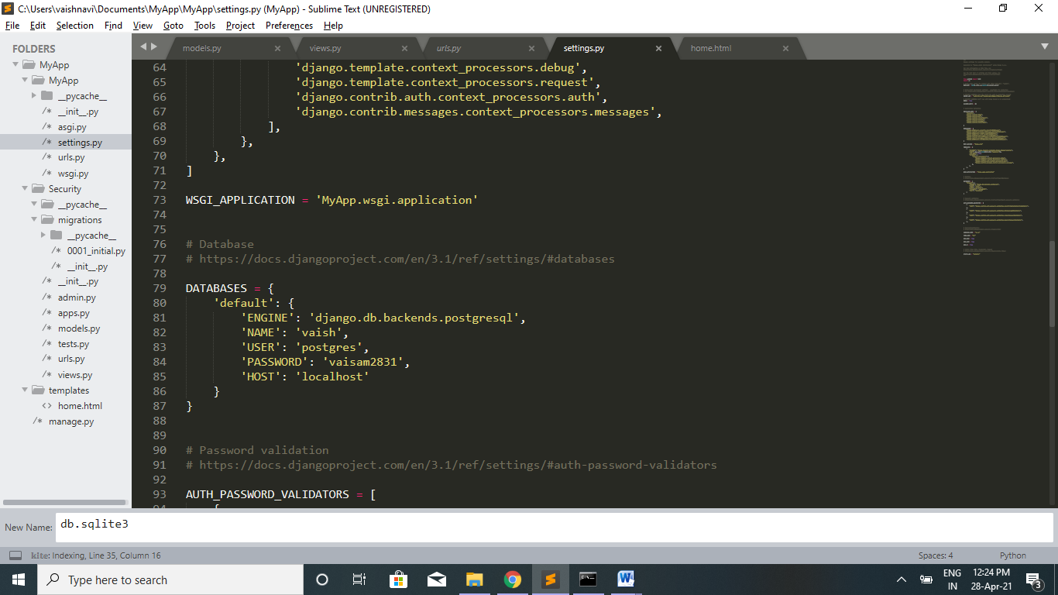

* The Admins interface is started

**python manage.py migrate**

**python manage.py createsuperuser**

To start the Admin Interface we have configured a URL for our admin interface. This helps the admin to change the data dynamically. In our cases the admin can update the user details.

* So we import the class that we have defined in the **models.py** folder into the **admins.py** file. If we import the class, table user_entries will be created in the postgresql database automatically with the fields mentioned in the class.

***Models.py***

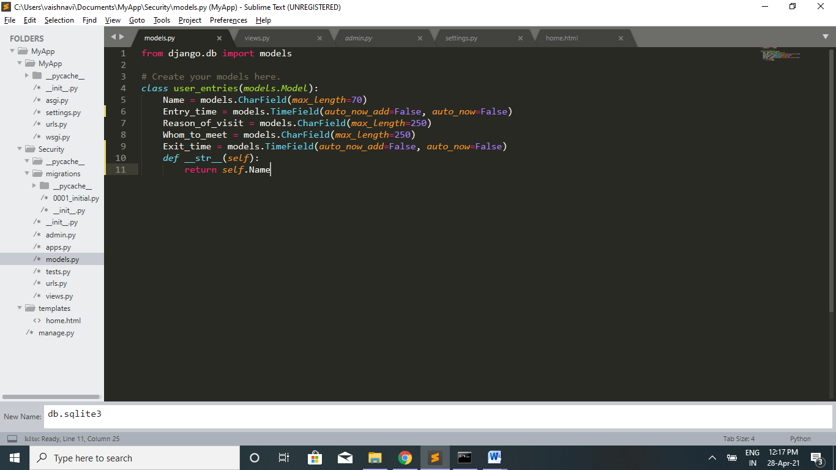

***Admins.py***

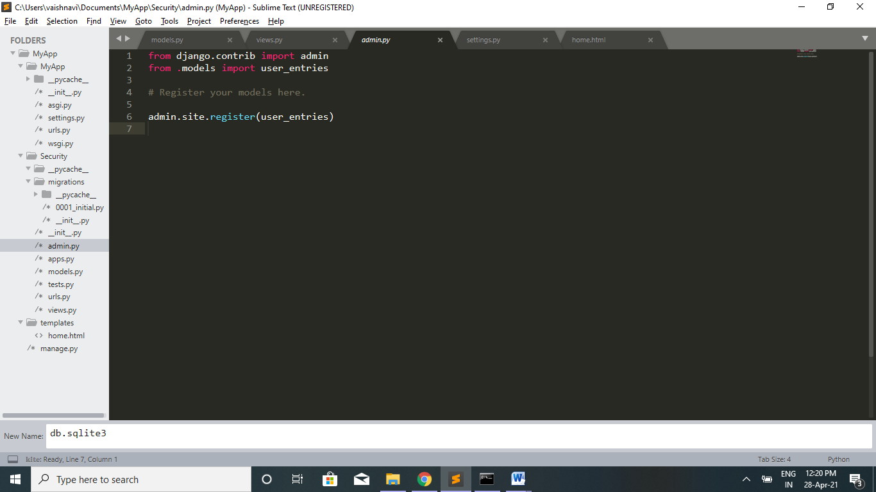

* After creating the super user we can login to the admin site and make changes in the user_entries table like we can add user details and edit it.

***Admin Login site***

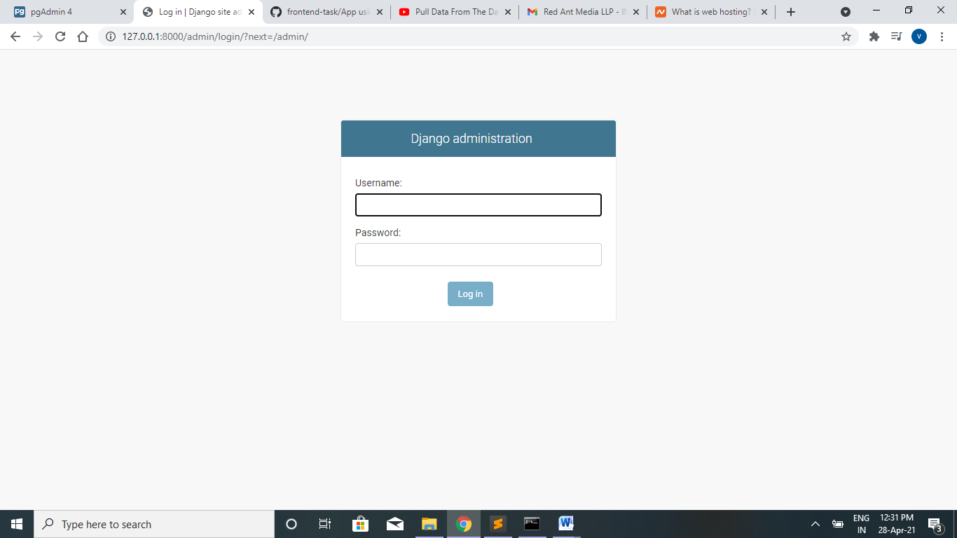 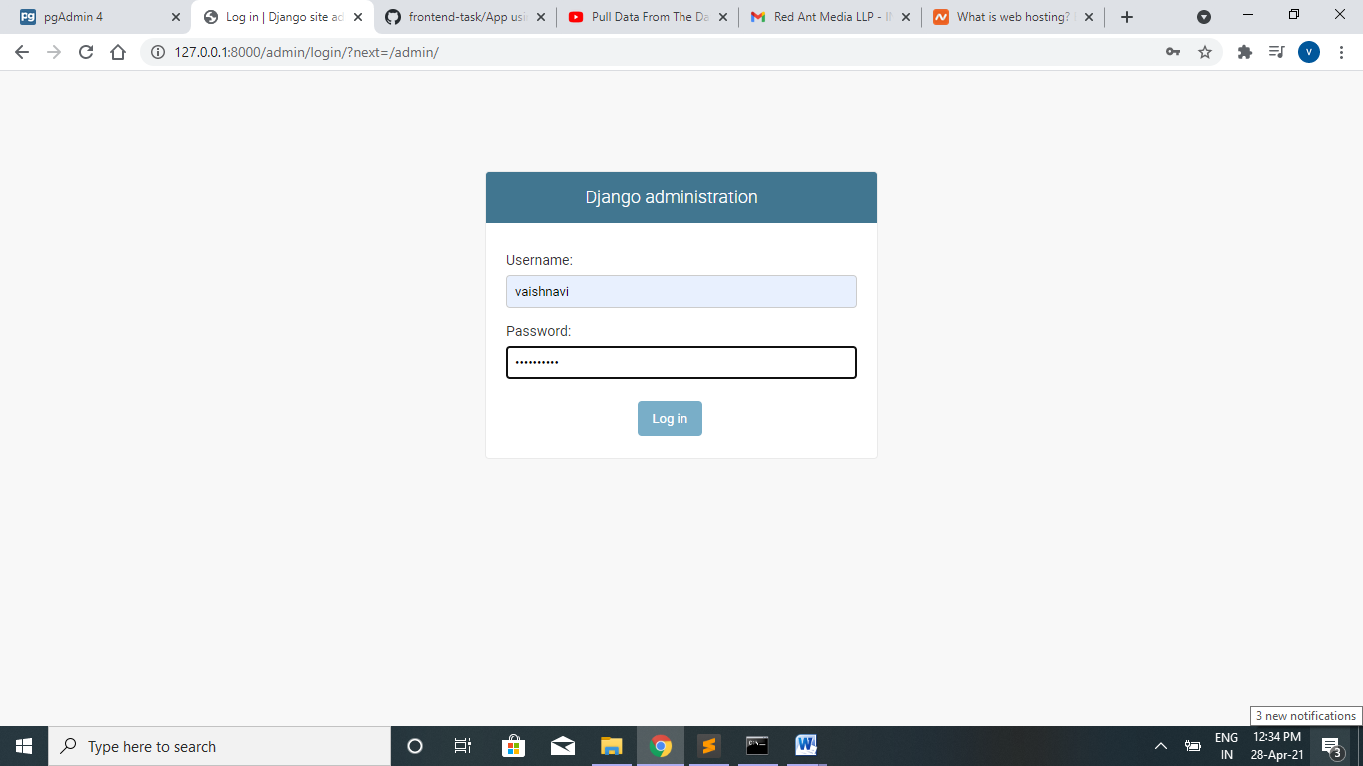

***Administration Site***

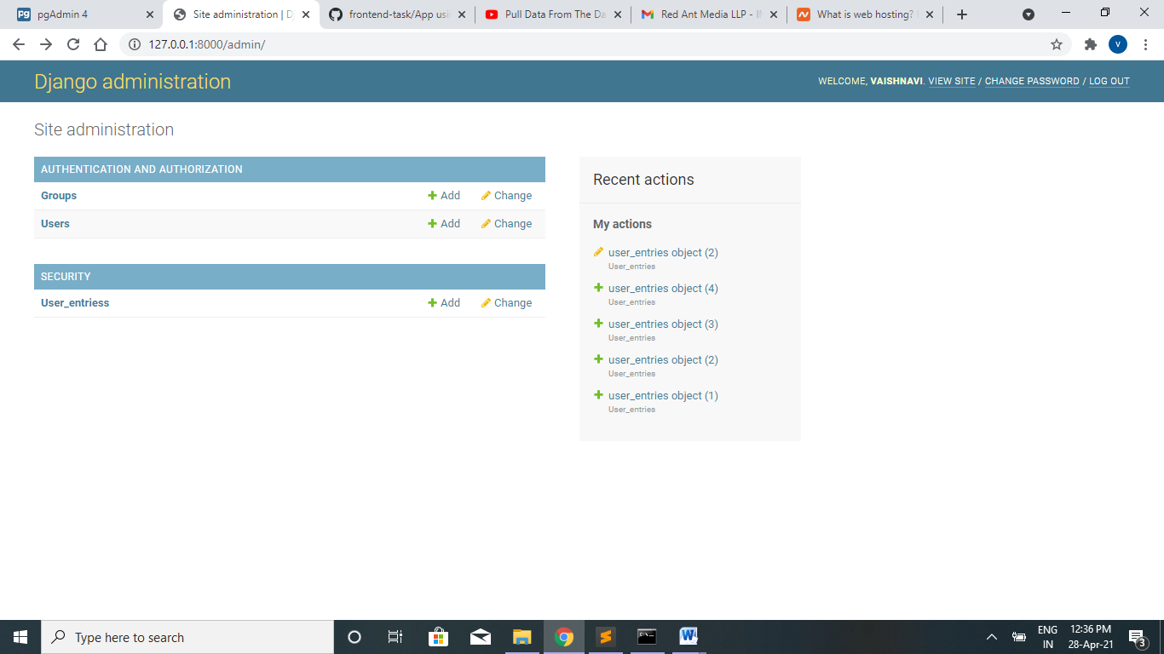

* If you want to add user details click the add button or if you want to edit the entered details click the change button.

***Add User Details***

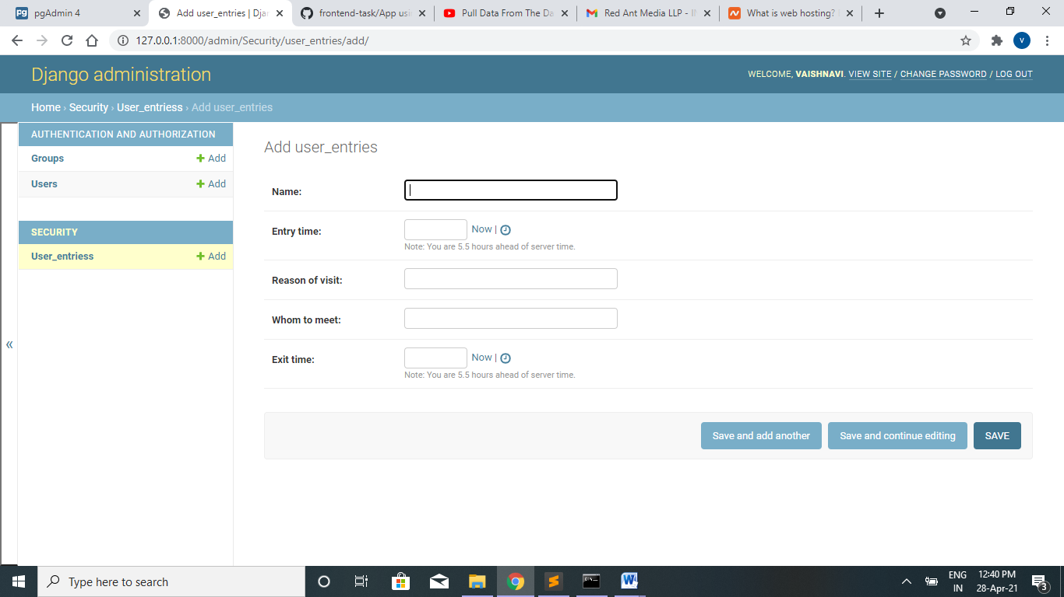

***User details Stored in Postgresql database***

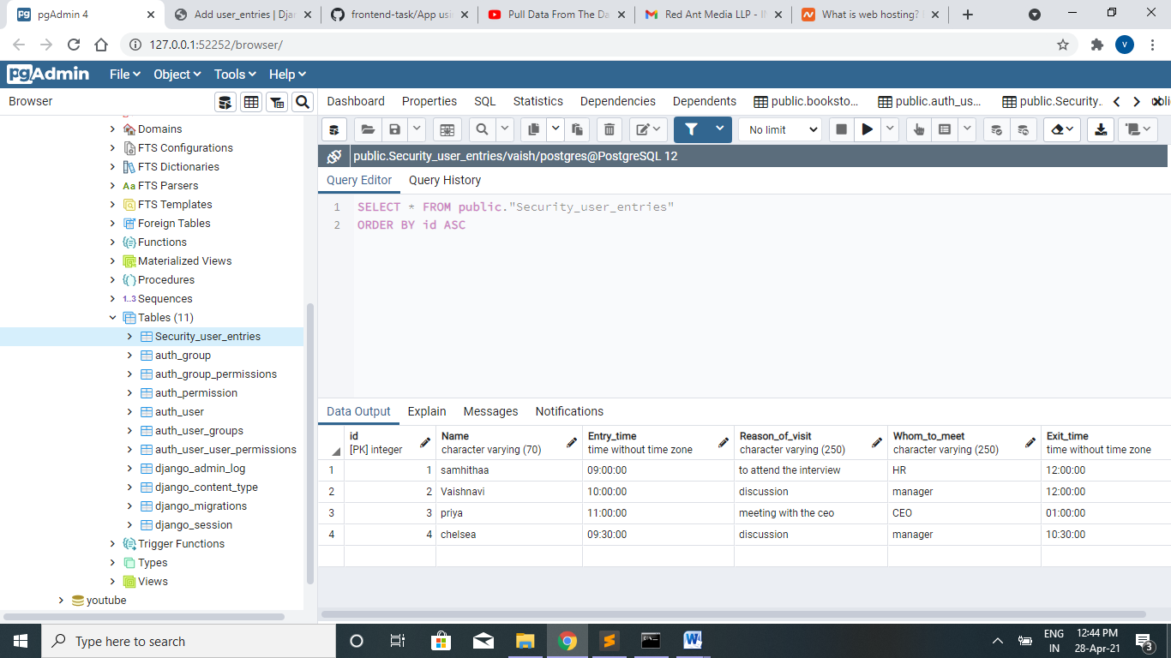

* After entering the user details we need to retrieve more information from the database. In order to do that we create an object for the table in the database and then use that in the html file and do querying there so that it is displayed in the webpage.

***Views.py***

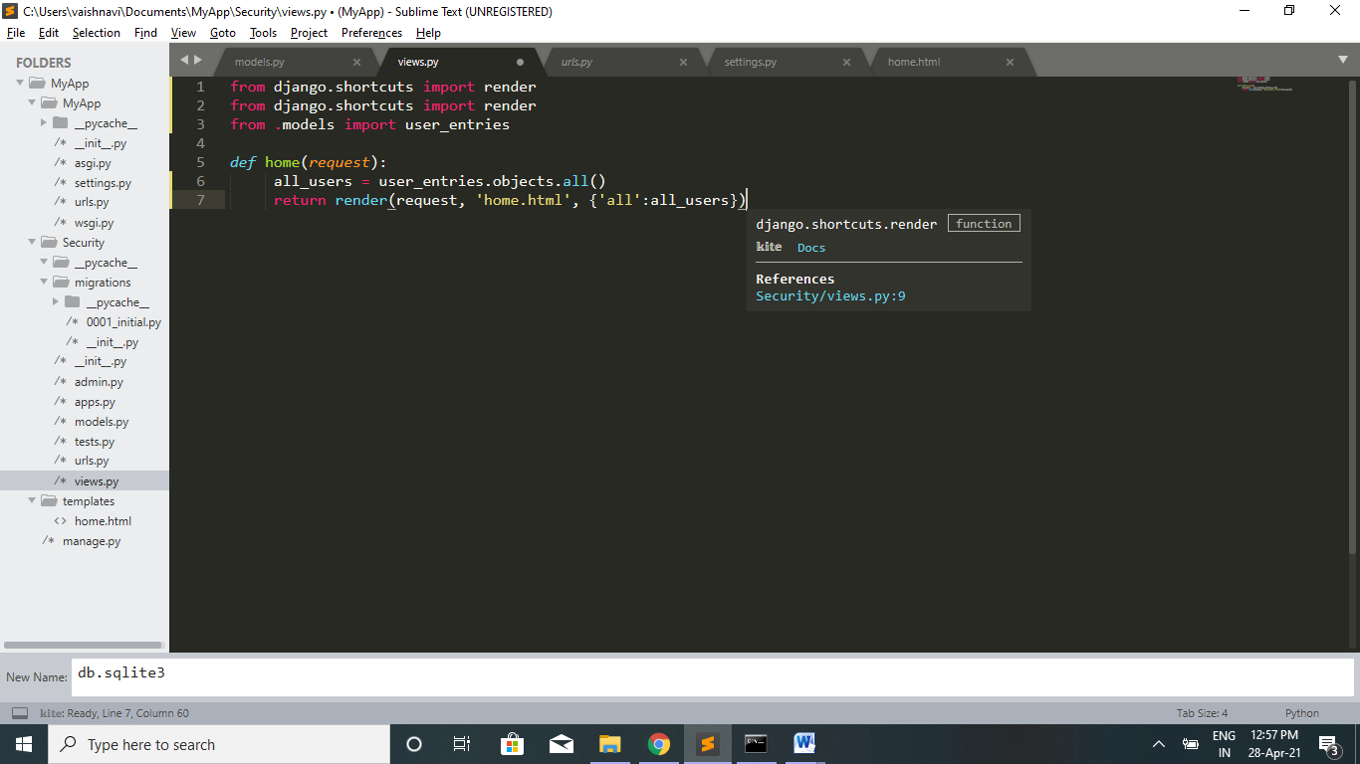

***Home.html (query)***

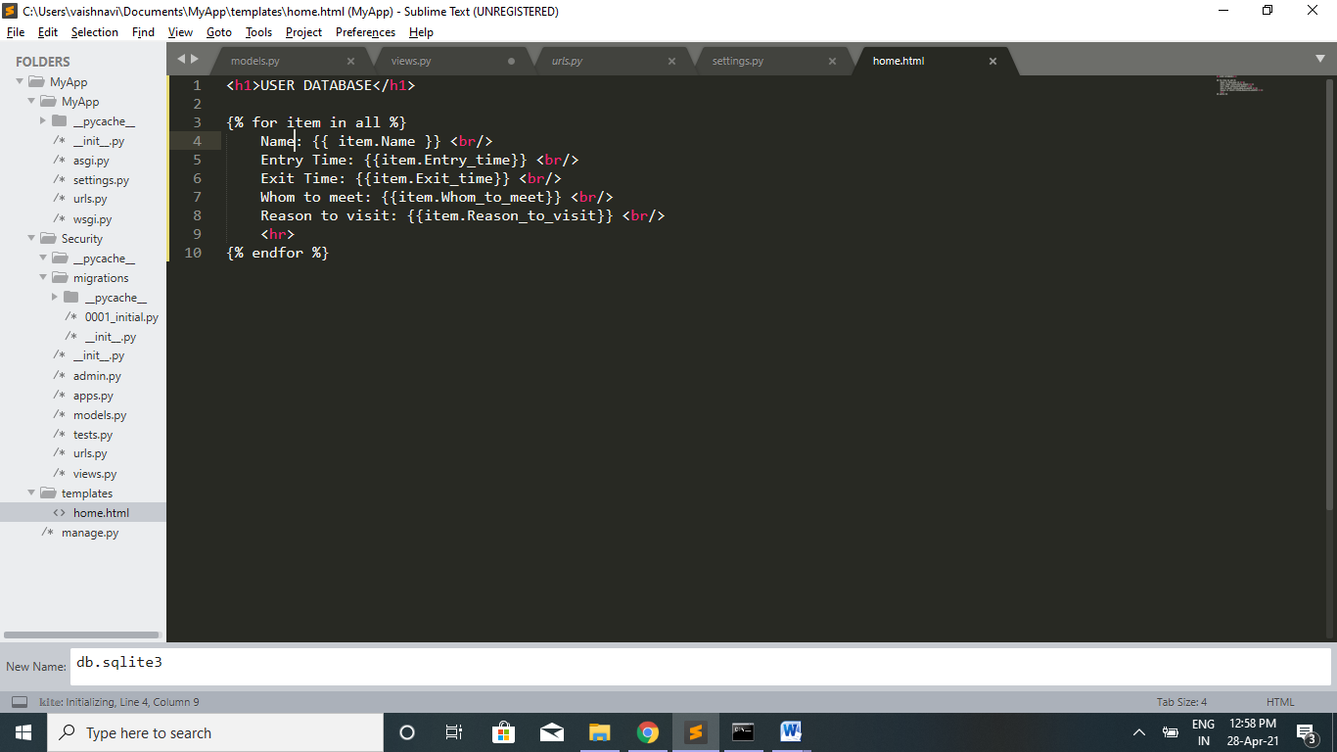

***Web Page***

